INSTALLING OF CUDNN ON RHEL 8

INSTALL NVIDIA GRAPGICS DRIVERS

Install up-to-date NVIDIA graphics drivers on your linux systemc

Procedure

1. Go to : <https://www.nvidia.com/Download/index.aspx?lang=en-us>
2. Select the GPU and OS version
3. Download and install the NVIDIA graphic driver ad indicated . for more information,select the ADDITIONAL INFORMATION tab for step-by-step installing a driver
4. Restart your system to ensure the graphics driver taken effect

INSTALLING THE CUDA TOOLKIT FOR LINUX

INSTALLING ZLIB

INSTALL THE ZLIB PACKAGE

#yum install zlib

DOWNLOADING CUDNN FOR LINUX

To download cuDNN , ensure you are registered for the

<https://developer.nvidia.com/developer-program>

Procedure

1.Go to : <https://developer.nvidia.com/cudnn>

2. click Download

3. complete the short survey and click submit

4.accept the terms and conditions . A list of available download version of cuDNN display

**INSTALL ON LINUX**

**The following steps describe how to build a cuDNN dependent program .**

**In the following sections:**

* Your CUDA directory path is referred to as /usr/local/cuda/
* Your cuDNN download path is referred to as <cudnnpath>

**TAR FILE INSTALLATION**

Before issuing the following , you’ll need to replace x.y and v8.x.x.x with your CUDA and cuDNN version and packages date

**Procedure:**

**1.Navigate to your <cudnnpath> directory contain cuDNN tar file**

**2.unzip the cuDNN package**

#tar -xvf cudnn-linux-x86_64-8.4.0.27_cuda11.7-archive.tar.xz

**3. copy the following files into the CUDA toolkit directory**

#cp cudnn-*-archive/include/cudnn*.h /usr/local/cuda/include

# cp -P cudnn-*-archive/lib/libcudnn* /usr/local/cuda/lib64

# chmod a+r /usr/local/cuda/include/cudnn*.h /usr/local/cuda/lib64/libcudnn*

**UBUNTU LOCAL INSTALLATION**

Download the ubuntu local repository installation packages, you’ll need to replace 11.7 and 8.4.0.27

PROCEDURE

1.Navigate to your <cudnnpath> directory the cuDNN RPM local installer file

2.Enable the local repository

sudo dpkg -i cudnn-local-repo-ubuntu2004- 8.4.0.27_1.0-1_amd64.deb

or

sudo dpkg -i cudnn-local-repo-ubuntu2004-8.4.0.27_1.0-1_arm64.deb

3.Import the CUDA GPG key.

sudo apt-key add /var/cudnn-local-repo-*/7fa2af80.pub

**4.Refresh the repository metadata**

#sudo apt-get update

**5.Install the runtime library**

#sudo apt-get install libcudnn8-8.4.0.27-1.cuda11.7

**6.Install the developer library**

#sudo apt-get install libcudnn8-devel-8.4.0.27-1.cuda11.7

**7.Install the code sample and the cuDNN library**

# sudo apt-get install libcudnn8-samples-8.4.0.27-1.cuda11.7

**PACKAGES MANAGER INSTALLATION**

* The package manager installation interfaces with your system’s packages manager.
* If the actual installation packages are available online, then package will automatically download and install

**UBUNTU NETWORK INSTALLATION**

**PROCEDURE**

**1.ENABLE THE REPOSITORY**

wget https://developer.download.nvidia.com/compute/cuda/repos/ubuntu2004/x86_64/cuda-ubuntu2004.pin

sudo mv cuda-ubuntu2004.pin /etc/apt/preferences.d/cuda-repository-pin-600

sudo apt-key adv --fetch-keys https://developer.download.nvidia.com/compute/cuda/repos/ubuntu2004/x86_64/7fa2af80.pub

sudo add-apt-repository "deb https://developer.download.nvidia.com/compute/cuda/repos/ubuntu2004/x86_64/ /"

sudo apt-get update

**Where ${OS} is ubuntu 2004**

**2. INSTALL THE cuDNN LIBRARY**

sudo apt-get install libcudnn8=8.4.0.27-1+cuda11.7

sudo apt-get install libcudnn8-dev=8.4.0.27-1+cuda11.7

WHERE :

* ${cudnn_version} is 8.4.0.27
* ${cuda_version} is cuda 11.7

**VERIFIYING THE INSTALL ON LINUX**

**To verify that cuDNN is installed and is running properly , compile the mnistCUDNN sample located in the /usr/src/cudnn_sample_v8**

**Procedure**

**1.copy the cuDNN sample to a writable path**

# cp -r /usr/src/cudnn_samples_v8/ $HOME

**2.Go to the writable path**

# cd $HOME/cudnn_samples_v8/mnistCUDNN

**3.compile the mnistCUDNN sample**

#make clean && make

**4.run the mnistCUDNN sample**

# ./mnistCUDNN

**If cuDNN is properly installed and running on linux systemc , you will see**

Test passed!

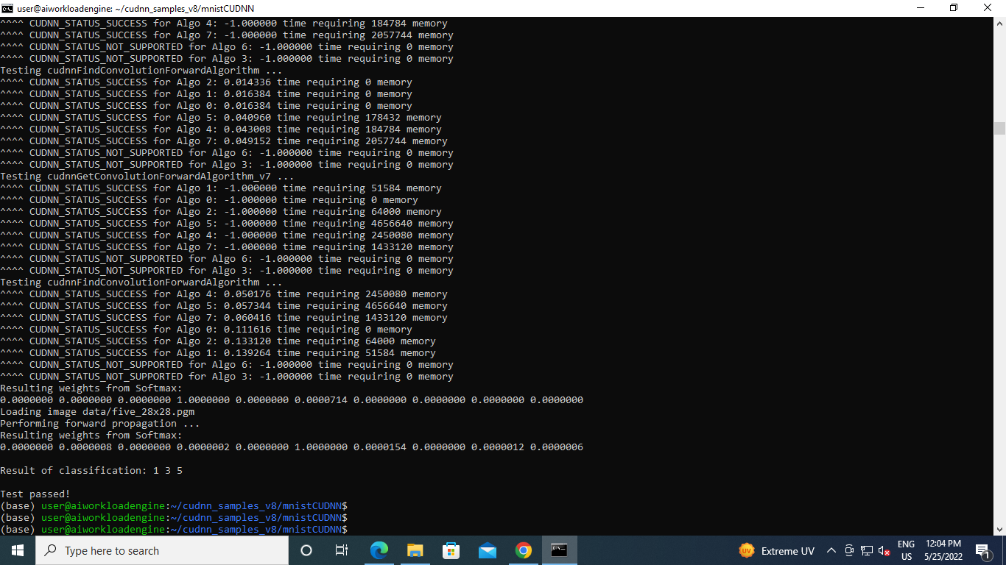

**NOTE :**

* In step 2 if you get no such file or directory

$mkdir mnistCUDNN

* **In step 3 if you below**

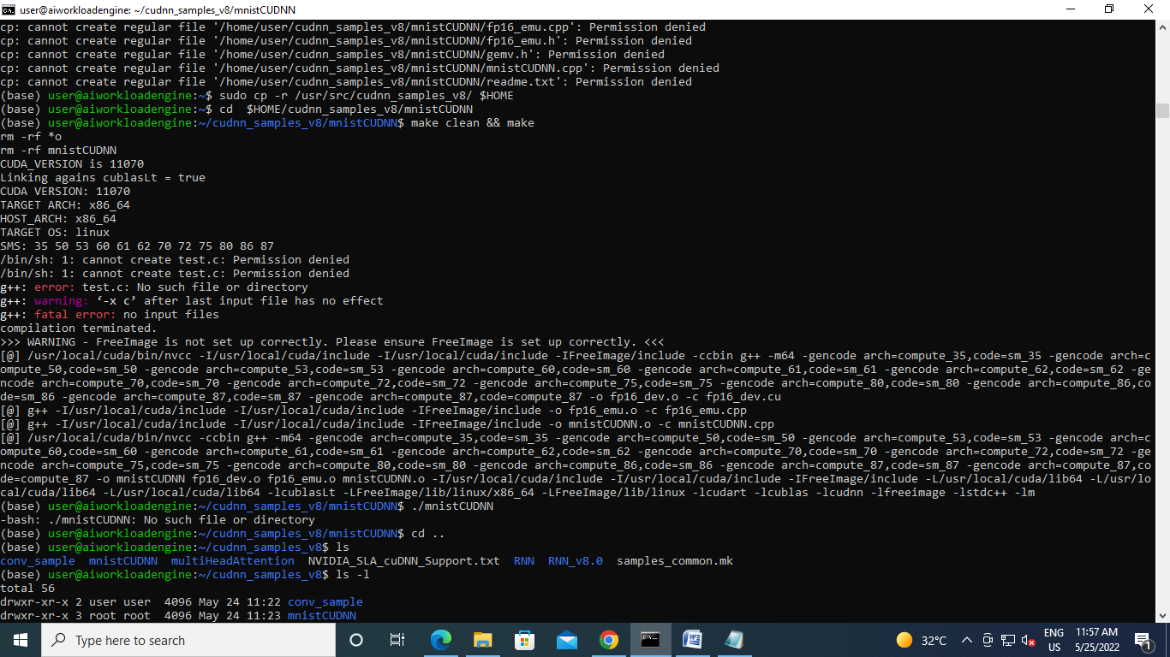

**#change permission for the folder** mnistCUDNN

Chmod 777 mnistCUDNN

* **Again you get the below problem**

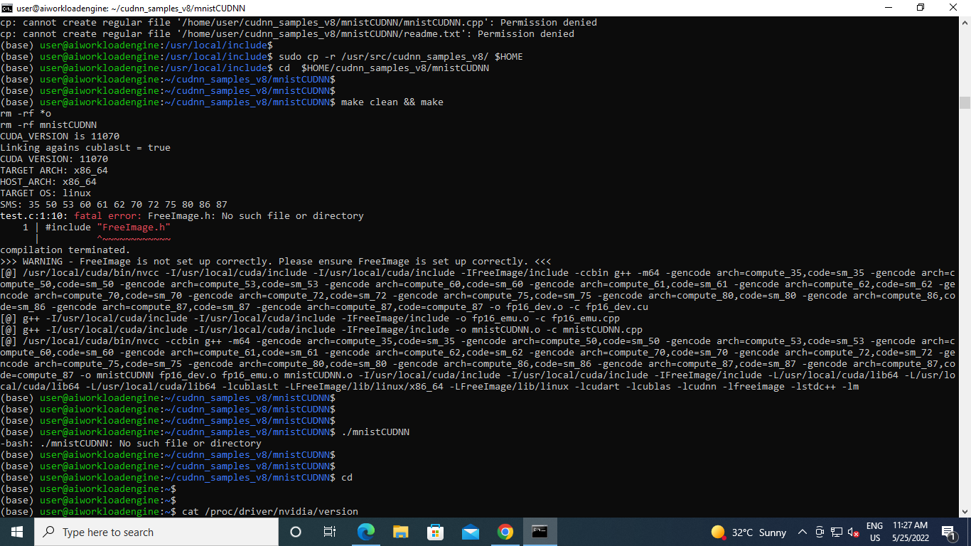

* **Type the below command**

sudo apt-get install libfreeimage3 libfreeimage-dev

**To check cuda**

$nvidia-smi